**Altium Download:**

1. Follow the below link and click on the .zip download:

<ftp://altiumdownload.ece.ufl.edu/pub/Altium%20Install/Altium%2019/Altium%2019%20zip/>

1. Once finished downloading, extract the files to whatever destination you want.
2. Once inside your destination folder, click on the AltiumDesigner19Setup.exe file.

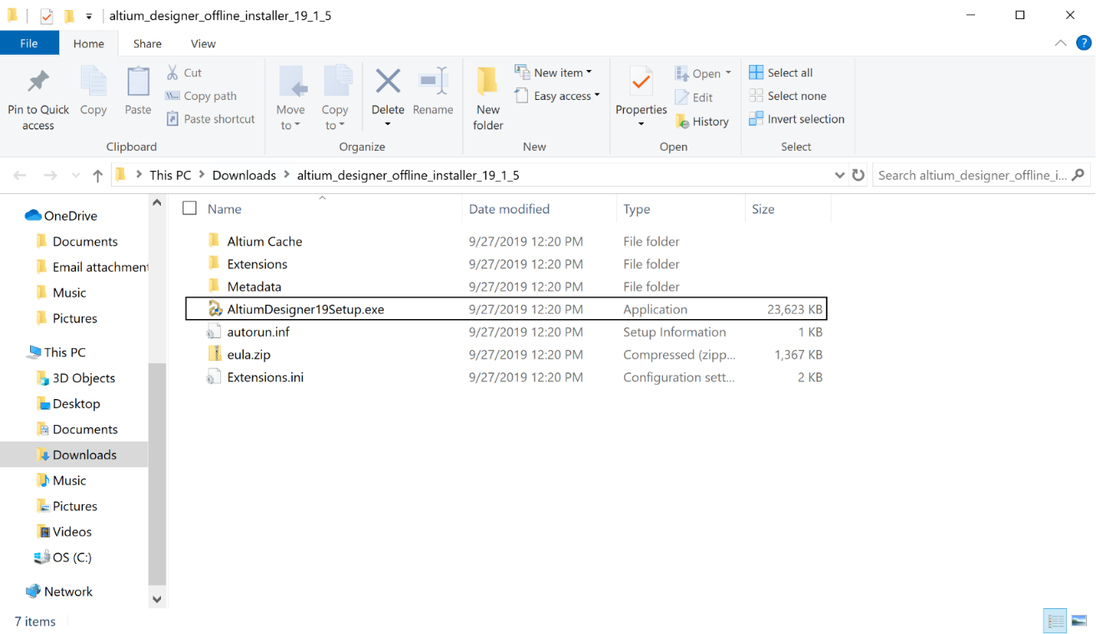

1. Follow through the default installation settings as shown below.

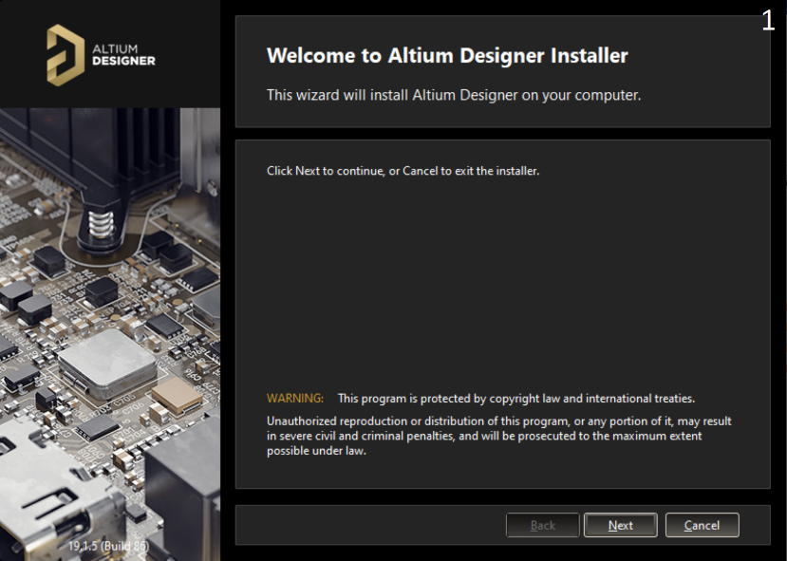 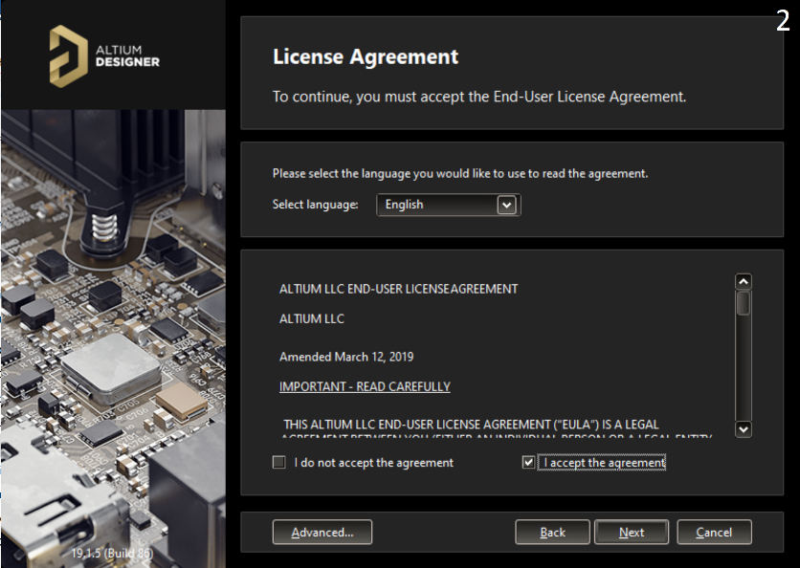

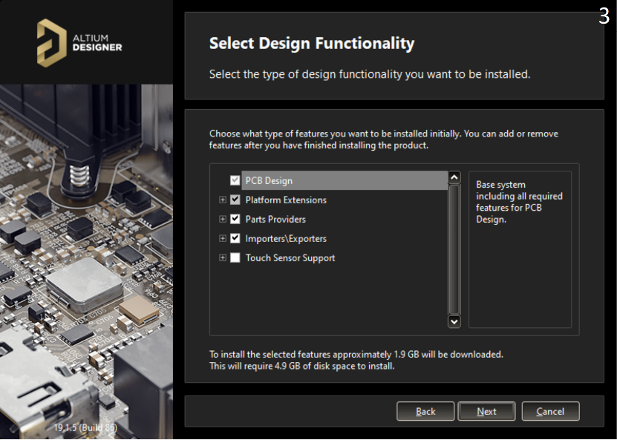 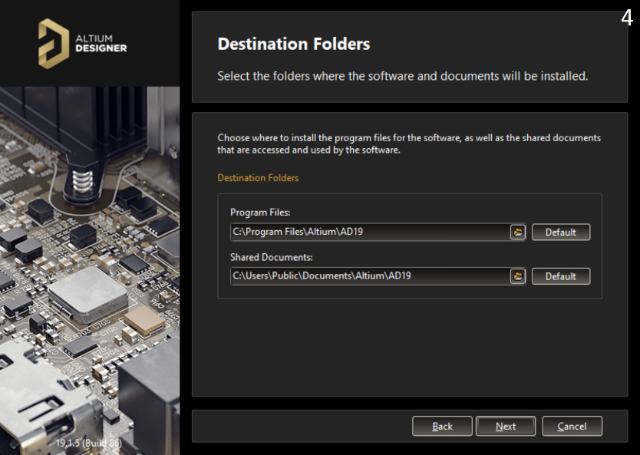

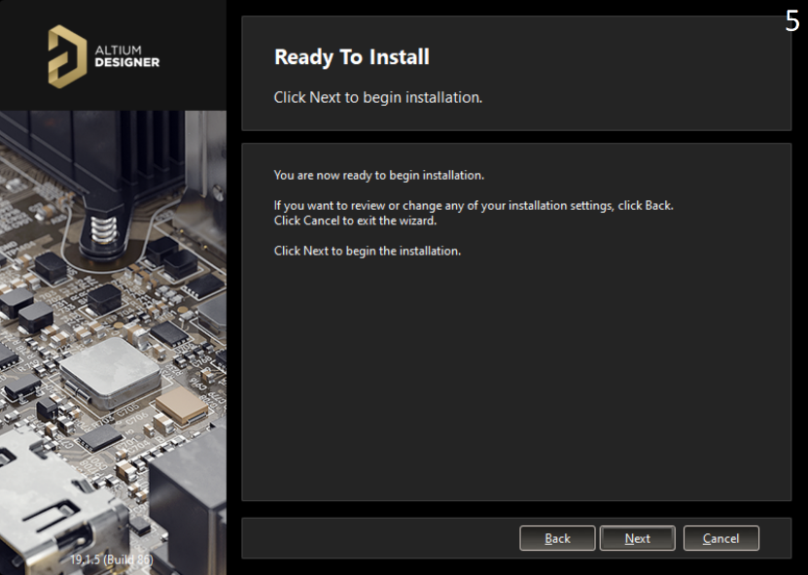 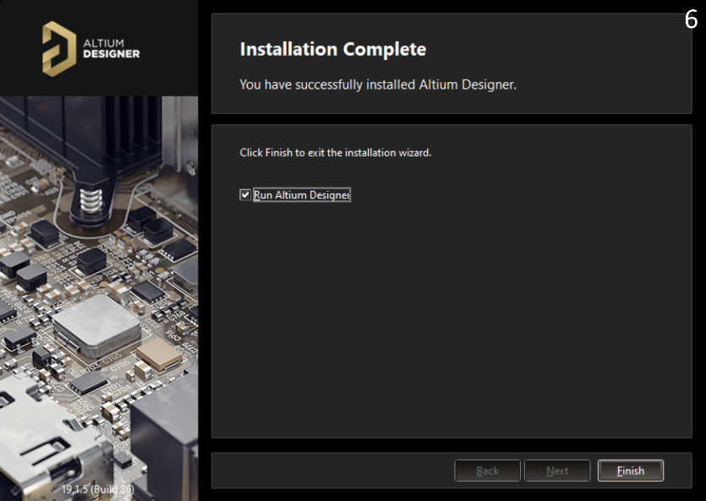

1. Once installed and opened you should see the below screen:
2. Click on “Setup Private License Server”

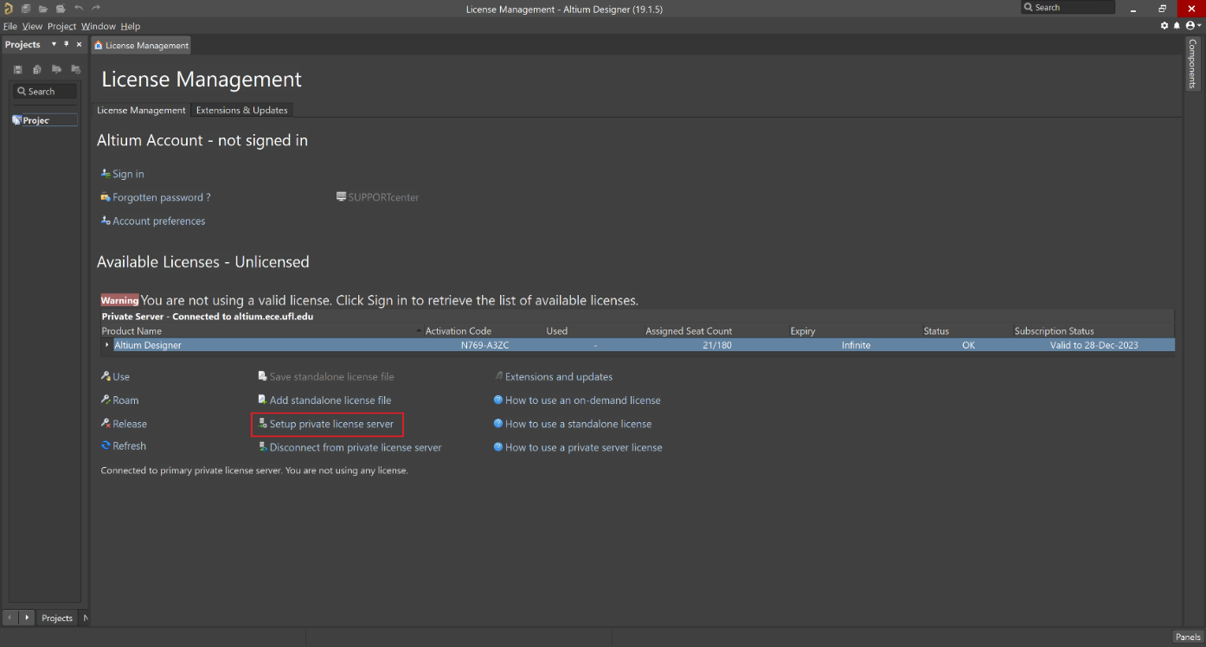

1. Set up the screen as shown below (make sure that you’re on the UF network):

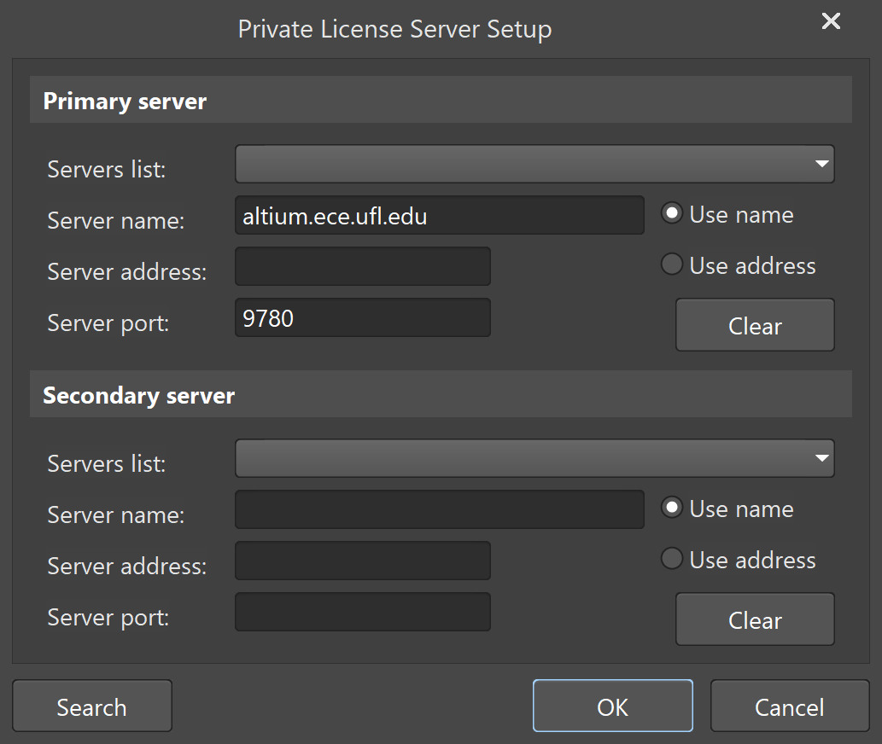

1. If you did everything correctly, you should see the following screen:

